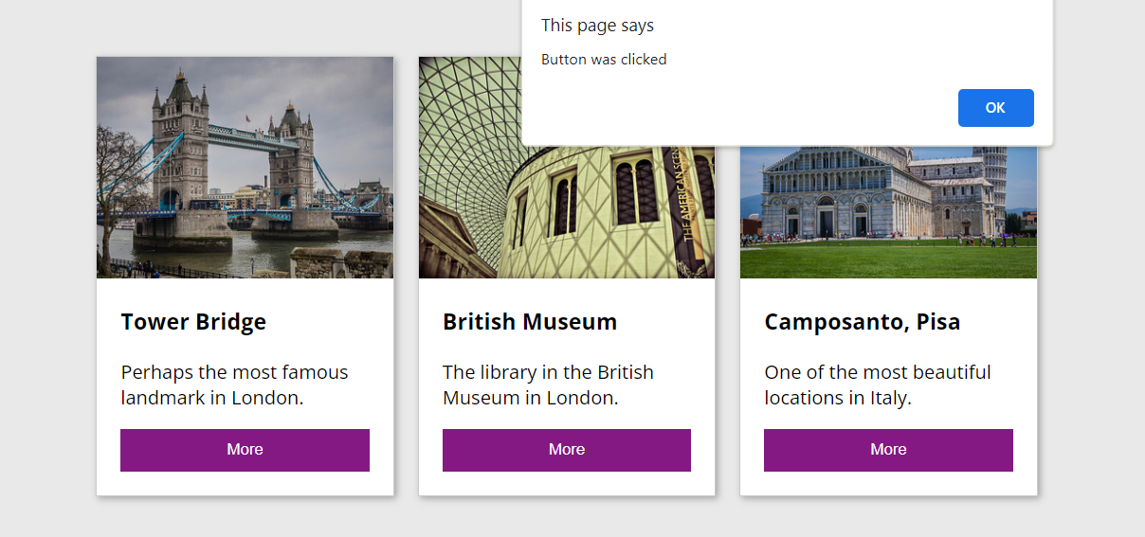

Alert for clicking the “More” button

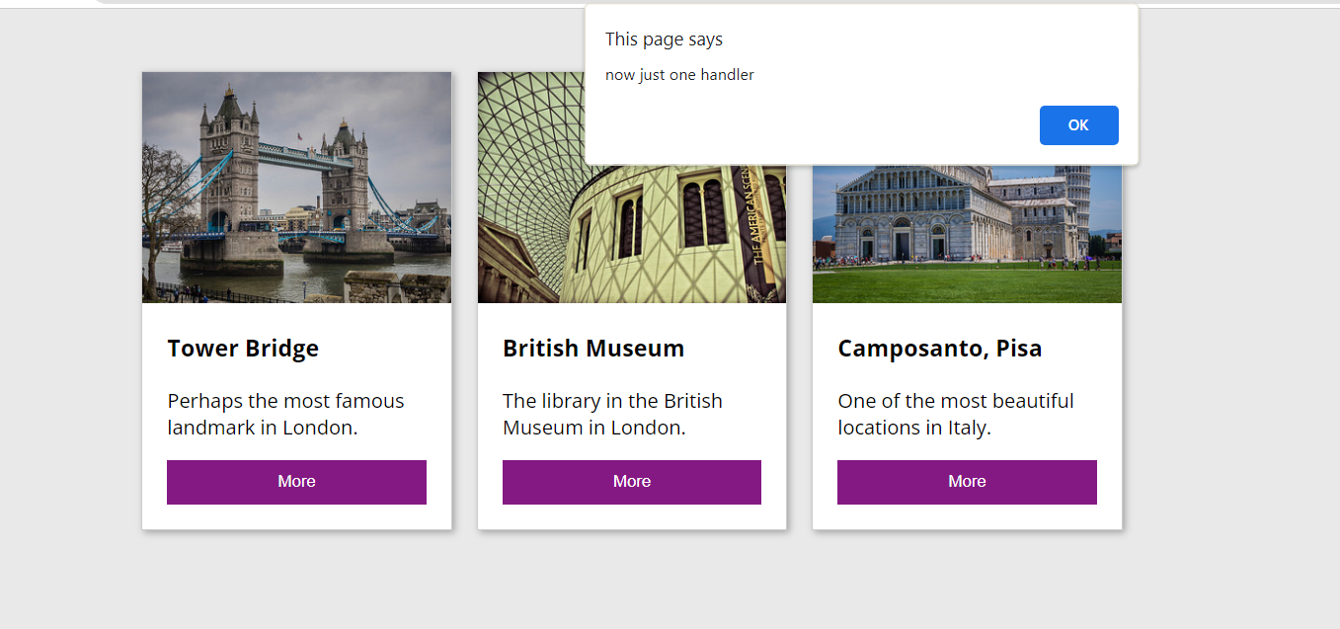

Every button now displays the same alert

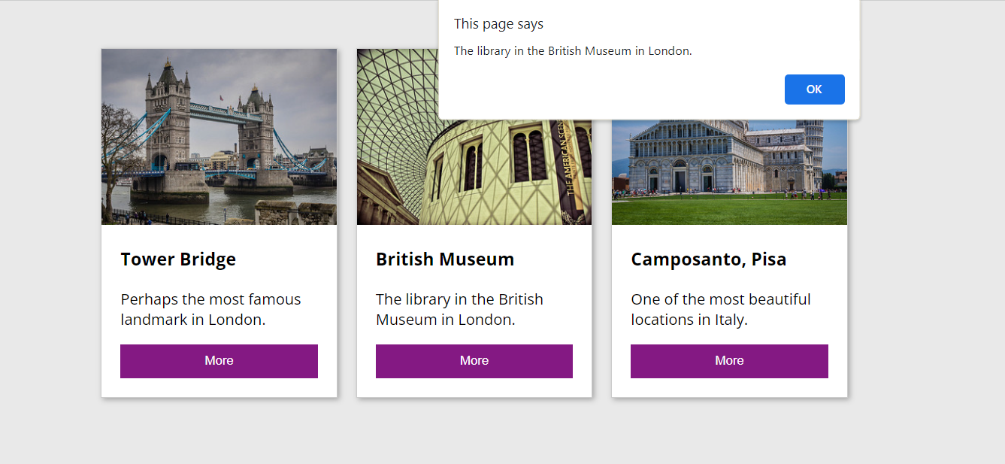

The textContent is displayed

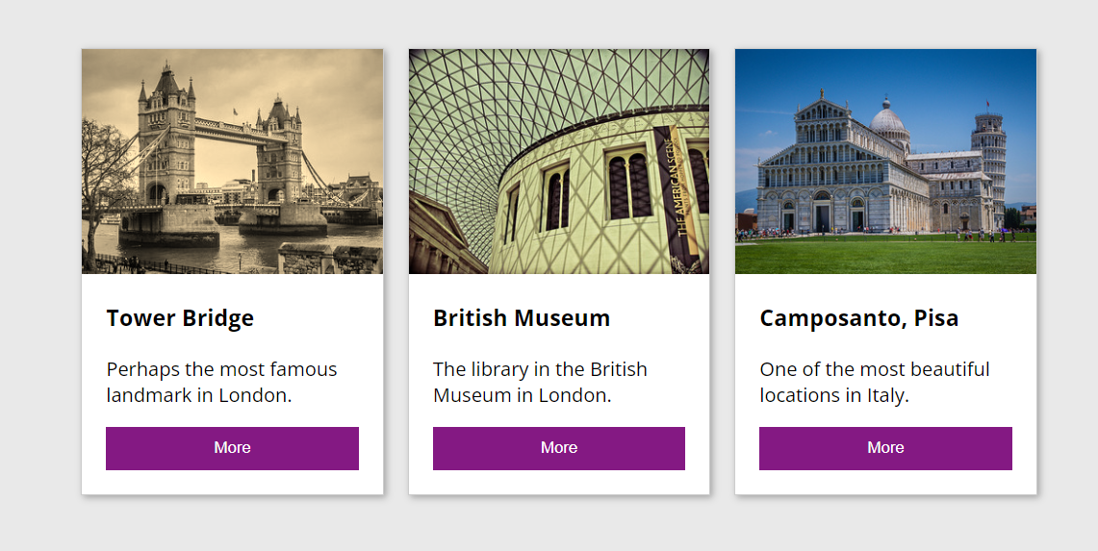

Applied sepia to the images

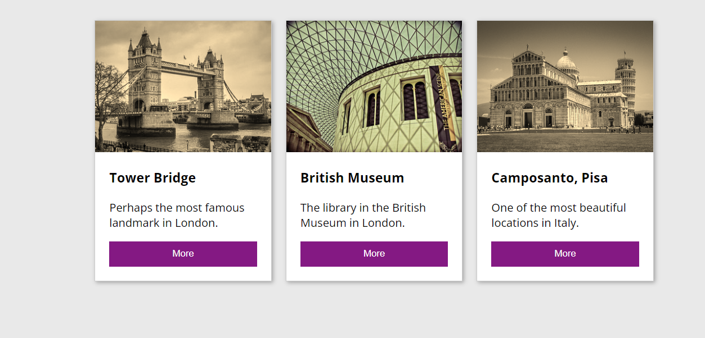

Used the toggle to apply sepia on each image

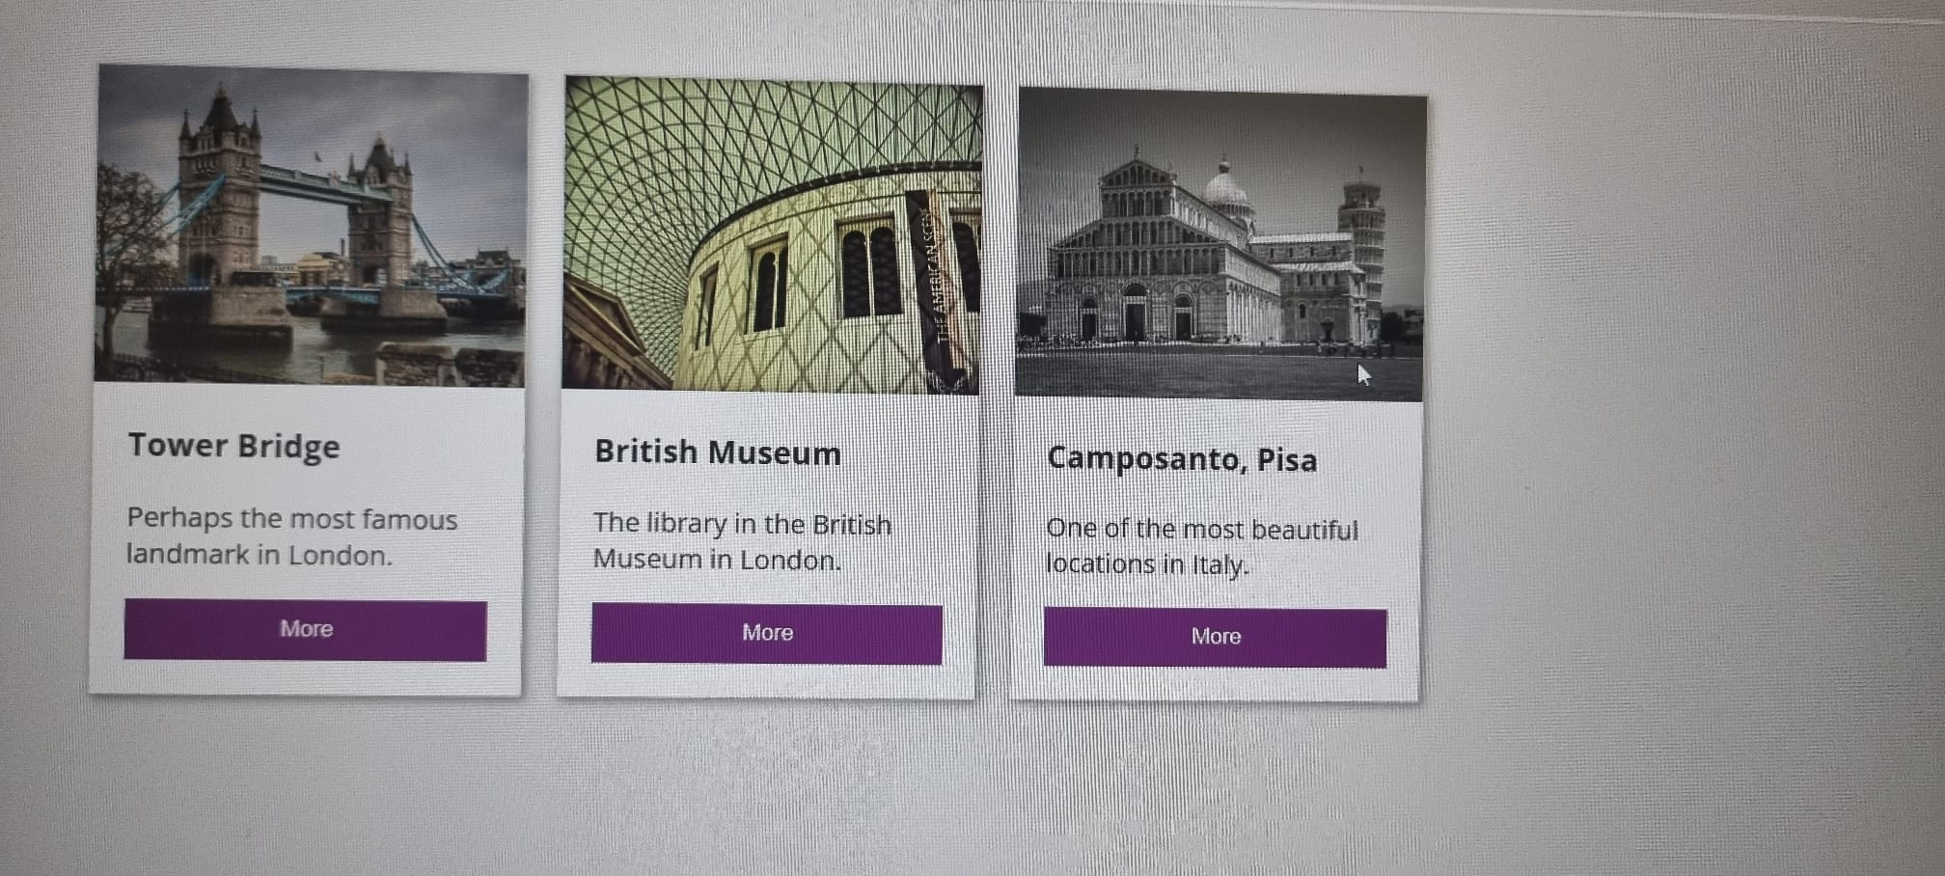

The grayscale works differently than the sepia because it’s not like the sepia which is a CSS class that can be toggled on and off, the CSS style needs to be called to use grayscale

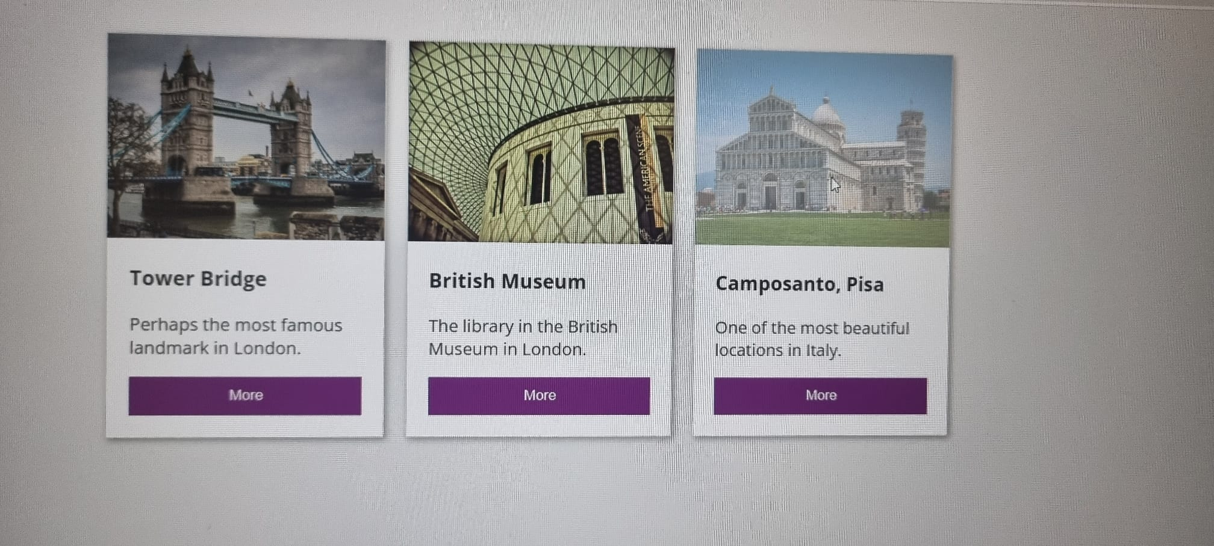

Used the opacity CSS style when the mouse enters the image the opacity is decreased to 0.2 and when the mouse leaves it returns to the original full opacity (1)

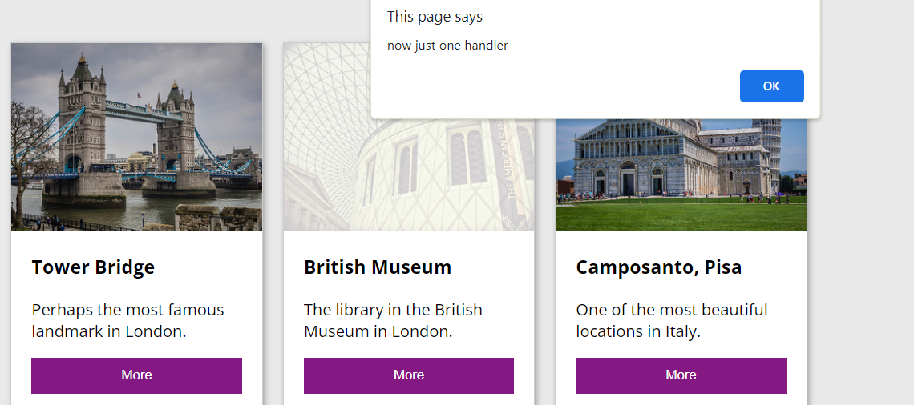

Apply alert to cards